Primary Source: http://greeneagle20.blogspot.com/2011/02/greek-culture.html

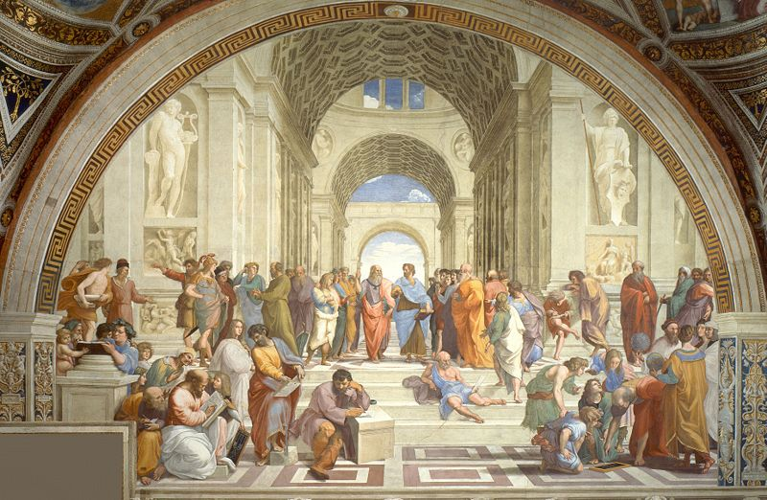

Questions:
- What do you see in this image?
- What various pieces of art do you see in the image?
- What pieces of art do we still see today in our culture?

Read or skim through the book, What did the Ancient Greeks do for me? By Patrick Catel. Look at the section that talks about architecture. Have the class look at the pictures and compare them to what they see here. After, ask them the following questions:
- What do you see in What did the Ancient Greeks do for me? that is similar to what you see in the image?
- In your own opinion, did the illustrator of What did the Ancient Greeks do for me? do a good job drawing the architecture?
- After looking at these two documents and comparing them, why do you think we still use this architecture today?

Primary Source: http://greeneagle20.blogspot.com/2011/02/greek-culture.html

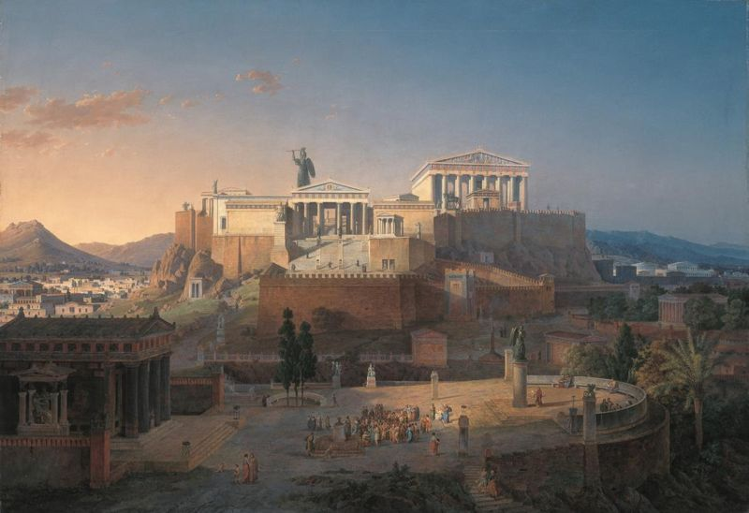

Questions:
- What do you see in the image?
- Where are the structures located in the village?
- What is similar to this layout to our culture today?

Have students read through Maps and cities, by Tim Cooke. Give them instructions to pick out 3 drawings or pictures of a city or town layouts. After they pick out their 3 drawing or pictures have them answer 3 questions:
- What did you notice between your 3 choices from Maps and cities was different from each other?
- What did you notice between your 3 choices from Maps and cities and the picture above was different?
- What did you notice between your 3 choices from Maps and cities and the picture above was the same?

Primary Source: http://www.in2greece.com/english/maps/ancient-greece-map.html
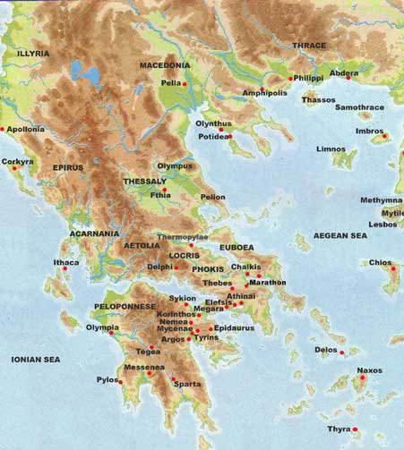

Questions:
- What do you see in the image?
- What current day country do you think this is?
- What geographical features do see on the map?
- What geographical features caused trouble for travelers in ancient Greece?
- Do you think this map is a primary document? Why or why not? Explain.

Pull up on the screen or on the board in the front of the class a map of where ancient Greece is currently located. Ask them to point out where major cities were located and also ask them where major battles took place. You could go on to ask them if they have learned where the ancient Greece cities and current day Greece cities are located, what major geographical features are located in Greece and what role they played in the development of the civilization. You could use the link: http://content.answcdn.com/main/content/img/factbook/maps/gr-map.gif to show the difference between the two civilizations.
Ending Activity: To show that the kids understand what they have learned in the 3 different activities we can do a small class presentation activity. Split the class into 3 groups. One group focuses on Geography, one on Architecture and one focusing on cities and towns. Each group will be given 3 questions and will create one drawing that the group comes up with. After they answer each question and create their drawing, they will be required to explain the answer they got for each question and explain in detail their group drawing. They will be required to explain what the drawing was about and why they chose to draw it.
Geography Questions:
- What geographical feature allowed the Greeks to travel, trade, and escape from danger easily?
- What current country is across the sea from Greece?
- What geographical feature divided the country and hindered movement of the people of Greece?

Architecture Questions:
- What is the name of the sport stadium that the Greeks used?
- What architectural feature do we see on the front of the White House?
- What was the most common piece of architecture that we saw in the primary documents?
Cities Questions:
- How were the ancient cities laid out?
- What was located in the middle of the city?
- Do we still see the city layout today in our society? If so, where is it seen more commonly?

How this relates to the CC: All 6th grade standards
- Reading Standards for Literature: 6.Explain how an author develops the point of view of the narrator or speaker in a text. a. Explain how an author’s geographic location or culture affects his or her perspective.
- Reading Standards for informational text: 9. Compare and contrast one author’s presentation of events with that of another (e.g., a memoir written by and a biography on the same person). a. Use their experience and their knowledge of language and logic, as well as culture, to think analytically, address problems creatively, and advocate persuasively.
- Writing Standard: 1.Create and present a text or art work in response to a literary work. A.Develop a perspective or theme supported by relevant details. b. Recognize and illustrate social, historical, and cultural features in the presentation of literary texts. c. Create poetry, stories, plays, and other literary forms (e.g. videos, art work)

- Speaking and Listening: 1.Engage effectively in a range of collaborative discussions (one-on-one, in groups, and teacher-led) with diverse partners on grade 6 topics, texts, and issues, building on others’ ideas and expressing their own clearly

a. Come to discussions prepared, having read or studied required material; explicitly draw on that preparation by referring to evidence on the topic, text, or issue to probe and reflect on ideas under discussion.
b. Follow rules for collegial discussions, set specific goals and deadlines, and define individual roles as needed.
c. Pose and respond to specific questions with elaboration and detail by making comments that contribute to the topic, text, or issue under discussion.
d. Review the key ideas expressed and demonstrate understanding of multiple perspectives through reflection and paraphrasing.
e. Seek to understand and communicate with individuals from different perspectives and cultural backgrounds.
5. Speaking and Listening Standard: Include multimedia components (e.g., graphics, images, music, sound) and visual displays in presentations to clarify information.

How this relates to the EQ:
In order to answer these questions you must have some prior knowledge of the topic. After the activity the kids should be able to see several things that the Greeks have given us such as city lay out, and arts. They can then come to a conclusion that if Early Civilizations were not around to shape our culture we could have a much different world than we see today.

