Primary Source: http://www.in2greece.com/english/maps/ancient-greece-map.html
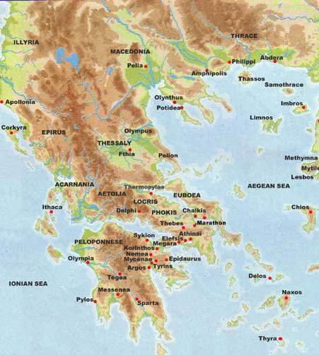

Questions:
- What do you see in the image?
- What current day country do you think this is?
- What geographical features do see on the map?
- What geographical features caused trouble for travelers in ancient Greece?
- Do you think this map is a primary document? Why or why not? Explain.

Pull up on the screen or on the board in the front of the class a map of where ancient Greece is currently located. Ask them to point out where major cities were located and also ask them where major battles took place. You could go on to ask them if they have learned where the ancient Greece cities and current day Greece cities are located, what major geographical features are located in Greece and what role they played in the development of the civilization. You could use the link: http://content.answcdn.com/main/content/img/factbook/maps/gr-map.gif to show the difference between the two civilizations.

